**TASK NO.1**

Create an application which can demonstrate all callbacks of a started service.

Activity_main.xml:

*<?*xml version="1.0" encoding="utf-8"*?>*<RelativeLayout xmlns:android="http://schemas.android.com/apk/res/android"  
 xmlns:app="http://schemas.android.com/apk/res-auto"  
 xmlns:tools="http://schemas.android.com/tools"  
 android:layout_width="match_parent"  
 android:background="@drawable/background"  
 android:layout_height="match_parent"  
 tools:context=".MainActivity">  
 <LinearLayout  
 android:layout_width="match_parent"  
 android:layout_height="match_parent"  
 android:orientation="vertical">  
 <Button  
 android:id="@+id/button"  
 android:layout_width="280dp"  
 android:layout_height="wrap_content"  
 android:layout_alignParentTop="true"  
 android:layout_gravity="center"  
 android:layout_marginTop="239dp"  
 android:onClick="startService"  
 android:text="Start Service" />  
 <Button  
 android:id="@+id/button2"  
 android:layout_width="280dp"  
 android:layout_height="wrap_content"  
 android:layout_alignParentTop="true"  
 android:layout_gravity="center"  
 android:gravity="center"  
 android:layout_marginTop="20dp"  
 android:onClick="stopService"  
 android:text="Stop Service" />  
 </LinearLayout>  
</RelativeLayout>

MainActivity.java:  
package com.example.lab07_task01;  
import android.content.Intent;  
import android.support.v7.app.AppCompatActivity;  
import android.os.Bundle;  
import android.view.View;  
import android.view.View.OnClickListener;  
import android.widget.Button;  
public class MainActivity extends AppCompatActivity implements View.OnClickListener {  
 private Button start,stop;  
 protected void onCreate(Bundle savedInstanceState){  
 super.onCreate(savedInstanceState);  
 setContentView(R.layout.*activity_main*);  
 start=(Button)findViewById(R.id.*button*);  
 stop=(Button)findViewById(R.id.*button2*);  
 start.setOnClickListener(this);  
 }  
public void onClick(View v) {  
 if(v == start){  
 startService(new Intent(this,MyService.class));  
 }  
 else if(v==stop){  
 stopService(new Intent(this,MyService.class));  
 } }  
}

MyService.java

package com.example.lab07_task01;  
  
import android.app.Service;  
import android.content.Intent;  
import android.media.MediaPlayer;  
import android.os.IBinder;  
import android.provider.Settings;  
  
public class MyService extends Service {  
  
 MediaPlayer player;  
 public IBinder onBind(Intent intent) {  
 return null;  
 }  
  
 @Override  
 public int onStartCommand(Intent intent, int flags, int startId) {  
 player=MediaPlayer.*create*(this, Settings.System.*DEFAULT_RINGTONE_URI*);  
 player.setLooping(true);  
 player.start();  
 return *START_STICKY*;  
 }  
public void onDestroy() {  
 super.onDestroy();  
 player.stop();  
 }  
}

**OUTPUT:**

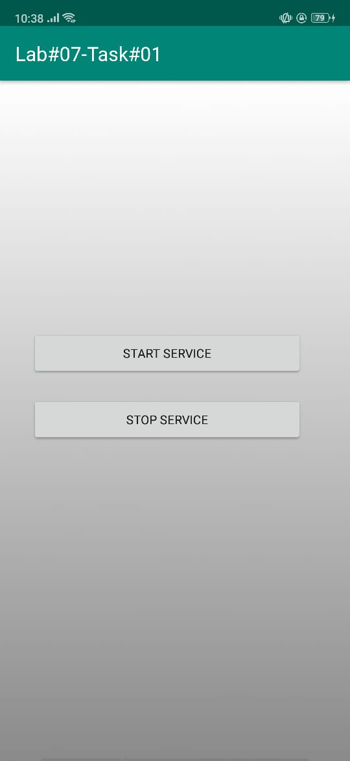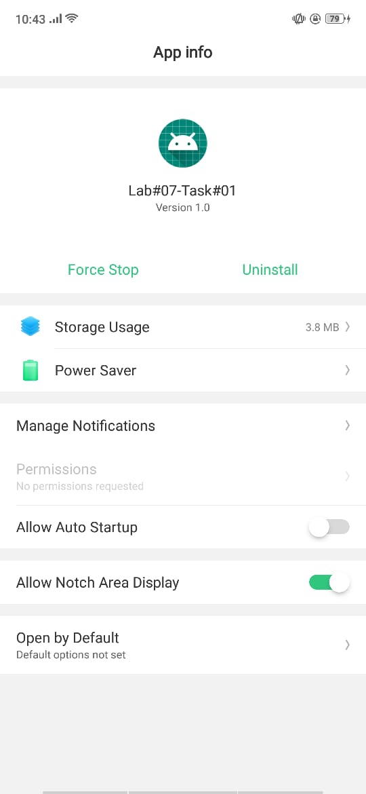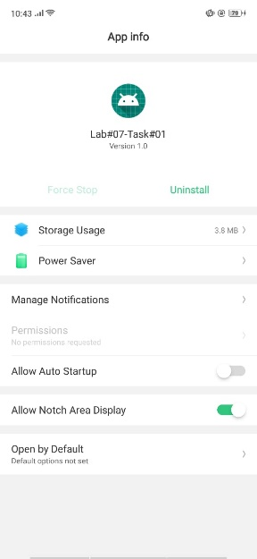

**TASK NO.2**

Create Started service that use android MediaPlayer class with default Settings of device.

Activity_main.xml:

*<?*xml version="1.0" encoding="utf-8"*?>*<RelativeLayout xmlns:android="http://schemas.android.com/apk/res/android"  
 xmlns:app="http://schemas.android.com/apk/res-auto"  
 xmlns:tools="http://schemas.android.com/tools"  
 android:layout_width="match_parent"  
 android:background="@drawable/background"  
 android:layout_height="match_parent"  
 tools:context=".MainActivity">  
 <LinearLayout  
 android:layout_width="match_parent"  
 android:layout_height="match_parent"  
 android:orientation="vertical">  
 <Button  
 android:id="@+id/button"  
 android:layout_width="280dp"  
 android:layout_height="wrap_content"  
 android:layout_alignParentTop="true"  
 android:layout_gravity="center"  
 android:layout_marginTop="239dp"  
 android:onClick="startService"  
 android:text="Start Service" />  
 <Button  
 android:id="@+id/button2"  
 android:layout_width="280dp"  
 android:layout_height="wrap_content"  
 android:layout_alignParentTop="true"  
 android:layout_gravity="center"  
 android:gravity="center"  
 android:layout_marginTop="20dp"  
 android:onClick="stopService"  
 android:text="Stop Service" />  
 </LinearLayout>  
</RelativeLayout>

MainActivity.java:  
package com.example.lab07_task01;  
import android.content.Intent;  
import android.support.v7.app.AppCompatActivity;  
import android.os.Bundle;  
import android.view.View;  
import android.view.View.OnClickListener;  
import android.widget.Button;  
public class MainActivity extends AppCompatActivity implements View.OnClickListener {  
 private Button start,stop;  
 protected void onCreate(Bundle savedInstanceState){  
 super.onCreate(savedInstanceState);  
 setContentView(R.layout.*activity_main*);  
 start=(Button)findViewById(R.id.*button*);  
 stop=(Button)findViewById(R.id.*button2*);  
 start.setOnClickListener(this);  
 }  
public void onClick(View v) {  
 if(v == start){  
 startService(new Intent(this,MyService.class));  
 }  
 else if(v==stop){  
 stopService(new Intent(this,MyService.class));  
 } }  
}

MyService.java

package com.example.lab07_task01;  
  
import android.app.Service;  
import android.content.Intent;  
import android.media.MediaPlayer;  
import android.os.IBinder;  
import android.provider.Settings;  
public class MyService extends Service {  
 MediaPlayer player;  
 public IBinder onBind(Intent intent) {  
 return null;  
 }  
  
 @Override  
 public int onStartCommand(Intent intent, int flags, int startId) {  
 player=MediaPlayer.*create*(this, Settings.System.*DEFAULT_RINGTONE_URI*);  
 player.setLooping(true);  
 player.start();  
 return *START_STICKY*;  
 }  
public void onDestroy() {  
 super.onDestroy();  
 player.stop();  
 }  
}

**OUTPUT:**

